**EE392 LAB2**

Hasan Alp Doyduk

S025015

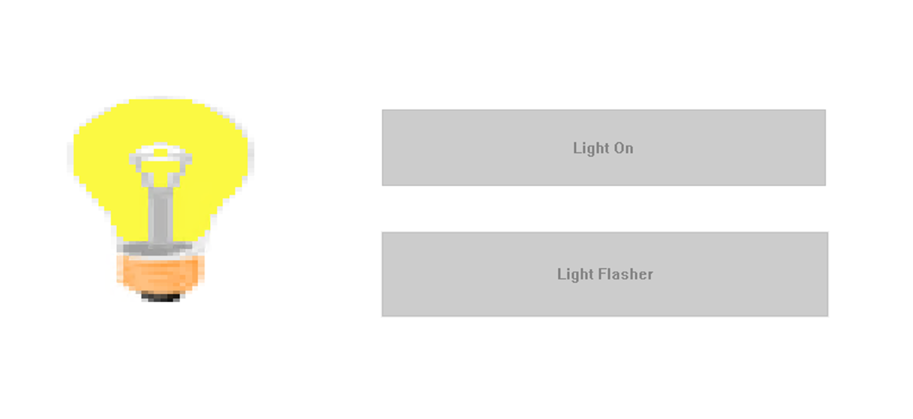

Figure . Part2_HMI

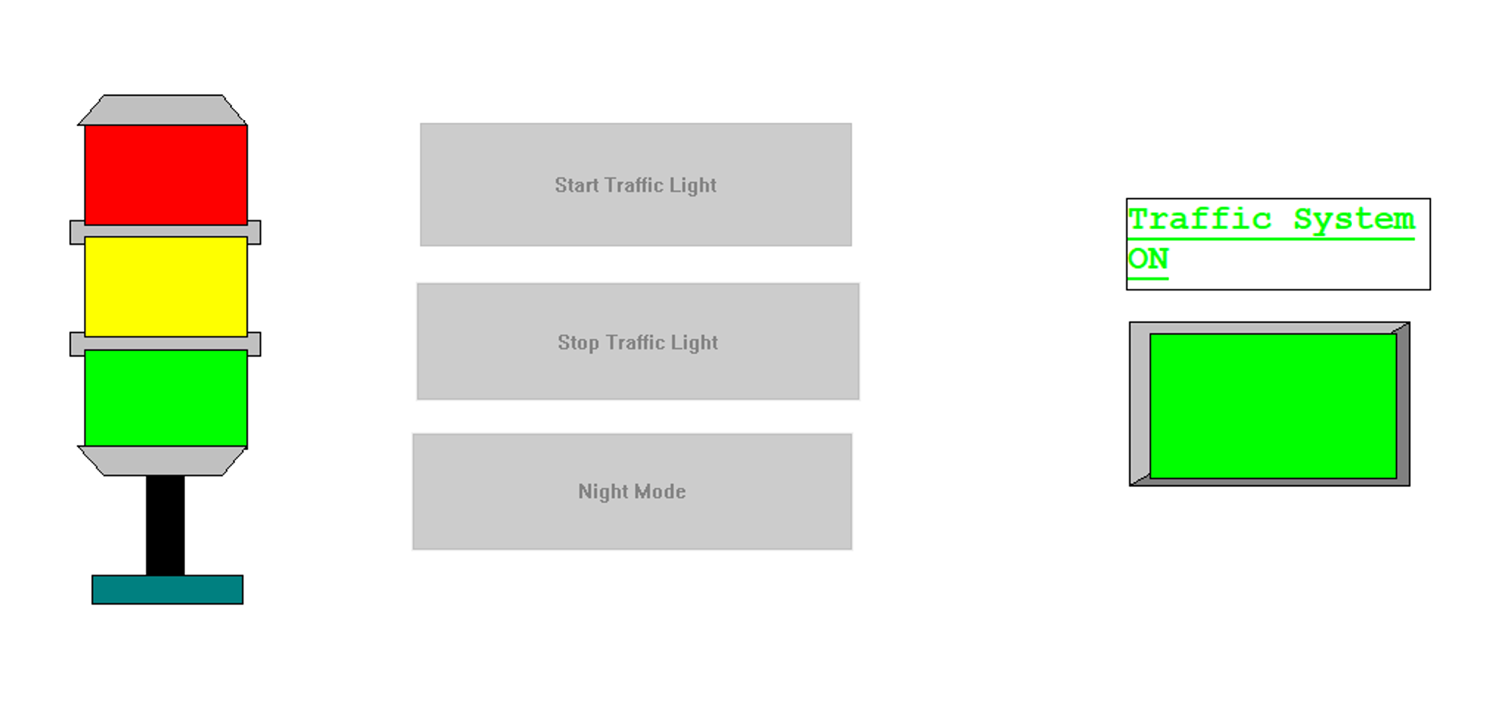

Figure . Part3_HMI

